Useful Phonics Websites for Parents

http://www.oxfordowl.co.uk/question/index/3
lots of information and guidance for parents/carers

http://www.phonicsplay.co.uk/ParentsMenu.htm
a selection of interactive games for all phonic phases. Mostly simple games.

www.ictgames.com/literacy.html
a great selection of games that link well with games in Letters and Sounds.

http://www.letters-and-sounds.com/
printable resources for each of the Letters and Sounds phonic phases, also links to games aligned with each phase.

http://www.ngfl-cymru.org.uk/vtc/ngfl/ngfl-flash/alphabet-eng/alphabet.htm
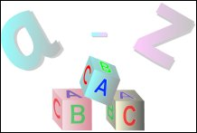
Letter names come up in alphabetical order

http://www.bbc.co.uk/schools/wordsandpictures/index.shtml
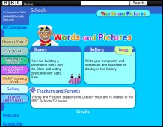
Activities for all phases

http://www.bbc.co.uk/schools/ks1bitesize/literacy/phonics/index.shtml
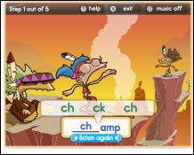
Phonic game with choice of difficulty (some HFWs, some vowel blends, very varied)

http://www.bigbrownbear.co.uk/magneticletters/
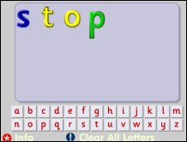
Make any words with this useful game.

http://www.phonicsinternational.com/hear_the_sounds/hear_the_sounds_1.htm
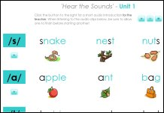 Useful page which demonstrates pronunciation of all sounds

