Rights Respecting School Award
Minutes of Steering Group Meeting
Date & Time: Friday 2nd February 2024 at 2:30 pm
Miss Ofosu welcomed all children to the meeting and explained that it will be a brief meeting to judge the Rights Respecting Mascots and announce the winner and discussed the Right Of The Month- Article 12- The Right to have an opinion and for it to be listened to.

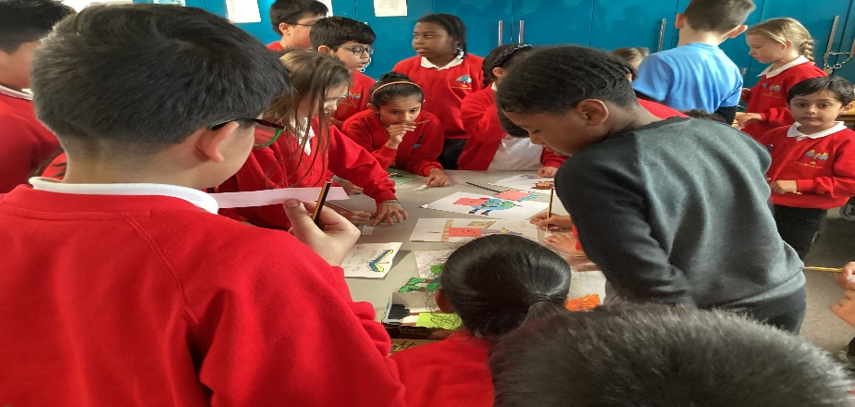

Attendees- Ayzah, Rushan, Thoren, Omar, Nikitha Saryu, Sami, Narjes, Aansh, Stefania, Nia, Yashree, Alicja, Rohan Jayden, Amy, Hasan, Rania, Marjon, Ishaaq, Aashi, Kabir, Patrick.
The steering group discussed the achievements of the RRSA work thus far.
These were including;
- A display board has been created that links to RRSA
- Assembly to introduce Rights Respecting Bronze Award
- RR introduced to parents- Parent forum
- Parents given – Our Rights Workbook
- Rights Respecting Mascot
- Curriculum
- Updated website
Playground Charter- Children agreed on creating posters for a playground charter for next session.
Next actions:
Steering group children to meet on 7th February 2024 (Lunchtime) to discuss assembly on climate change/ earth day.
Next full steering group meeting is on Friday 8th March 2023
Mrs Ofosu thanked everyone for their attendance with no other business, the meeting ended at 3PM.

