Like the phoenix we
Rise to our challenges
Strengthen our Learning and
Shine in our community

Remote Learning Policy

Introduced | Approved by | Date of next review
01/10/20  09/23 Reviewed | Provision and Effectiveness | On-going to reflect updates/reviews
Completed by: Annmarie Taylor-Kent-Headteacher

1. Aims

This remote learning policy for staff aims to:
- Ensure consistency in the approach to remote learning for pupils who aren’t in school
- Set out expectations for all members of the school community with regards to remote learning
- Provide appropriate guidelines for data protection
- Gives access to high quality remote education provision and resources

2. Use of remote learning
All pupils should attend school, in line with our attendance policy. Remote education is not viewed as an equal alternative to attendance in school.
Pupils receiving remote education will be marked absent in line with the Pupil Registration Regulations.
We will consider providing remote education to pupils in circumstances when in-person attendance is either not possible or contrary to government guidance.
This might include:
Occasions when we decide that opening our school is either:
- Not possible to do safely
- Contradictory to guidance from local or central government

Occasions when individual pupils, for a limited duration, are unable to physically attend school but are able to continue learning, for example because:

- They have an infectious illness
- They are preparing for or recovering from some types of operation
- They are recovering from injury and attendance in school may inhibit such recovery
- Their attendance has been affected by a special educational need or disability (SEND) or a mental health issue

The school will consider providing pupils with remote education on a case-by-case basis.
In the limited circumstances when remote learning is used, we will:
- Gain mutual agreement of remote education by the school, parents/carers, pupils, and if appropriate, a relevant medical professional. If the pupil has an education, health and care (EHC) plan or social worker, the local authority (LA) will also be involved in the decision
- Put formal arrangements in place to regularly review it and identify how to reintegrate the pupil back into school

Identify what other support and flexibilities can be put in place to help reintegrate the pupil back into school at the earliest opportunity
Set a time limit with an aim that the pupil returns to in-person education with appropriate support
Remote education will not be used as a justification for sending pupils home due to misbehaviour. This would count as a suspension, even if the pupil is asked to access online education while suspended.

3. Roles and responsibilities
3.1 Teachers
When providing remote learning, teachers must be working between 8.45 and 3pm (with a 1 hour lunchbreak)
If they’re unable to work for any reason during this time, for example due to sickness or caring for a dependent, they should report this using the normal absence procedure.
When providing remote learning, teachers are responsible for:
- Setting work

  - Teachers need to set work that reflects the sequence of learning outlined in the curriculum overviews so that knowledge and skills are built incrementally, with clarity about what is intended to be taught and practised in each subject.
  - Teachers must plan a programme that is of equivalent length to the core teaching pupils would receive in school

Good practice is considered to be:
    - 3 hours a day on average across the cohort for Key Stage (KS) 1, with less for younger children
    - 4 hours a day for KS2

  - Learning should as far as possible reflect the curriculum subjects taught over the day/week.
  - Teachers should use the Education Endowment Foundation learning sequence to support planning-activate, explain, practise, reflect and review
  - The Education Endowment Foundation (EEF) has found that the effectiveness of remote teaching is determined by many of the same factors as determine the effectiveness of live classroom teaching. For example:
  - ensuring pupils receive clear and frequent explanations of new content
  - supporting growth in confidence with new material through scaffolded practice
  - application of new knowledge or skills
  - enabling pupils to receive feedback on how to progress

At Wembley Primary School we will ensure that these elements are included in plans for remote teaching and learning
  - Where it is appropriate links should be made with Oak National Academy or other resource-at least 2 teaching videos that are linked to the school’s curriculum expectations should be uploaded every day.
  - Teachers will ensure that learning and tasks are set in relation to the child’s stage of development and SEND.
  - Teachers will use Active Learn Bug Club/Rapid Reader to ensure that children have access to reading books and that they are continuing to read fluently.
  - The work should be set by 3pm the day before
  - All lessons/tasks work should be uploaded to google classroom
  - Teachers must continue to liaise with their staff team and SLT member
  - When a child returns to school-assessments are completed to ensure that there are no gaps in a sequence of learning. If gaps are identified targeted support is put in place.

We will provide a laptop (dependant on numbers) to children who have no access to a device of their own to use at home. Devices will be made available at the start of the period of home learning. If we are unable to provide a device. We will ensure hard copies of the learning are provided.

(Teachers will not set long term projects or internet research activities)

- Providing feedback on work:

  - Pupil can send any completed work to teachers via google classroom
  - Feedback to follow our feedback policy. Teacher may use google forms as an assessment tool.
  - Teachers to gauge how well pupils are progressing through the curriculum, using questions and suitable tasks-this will enable teachers to adjust the pace or difficulty of what is being taught in response to questions or assessments.
  - Teachers should respond to any emails and /or comments on google classrooms from parents/children within 48hours (not including weekends)

- Keeping in touch with pupils who aren’t in school and their parents

- Emails/Messages received from parents and pupils are to be checked between 9am and 3pm, Mon- Fri. Emails must be replied to within 48hrs (excluding the weekend). Only send replies between these times.
- Any issues that are received are to be dealt with professionally by the class teacher. If necessary, teachers to contact a member of SLT for advice.

In the case of a whole school Lock down/Closure

- Google Meet sessions should happen once a day During the morning session, teachers are to take a register and explain the timetable for the day during their Google Meet session.

If children do not attend the session, contact is to be made with those pupils via a telephone call from a withheld number. Contact should be polite and encouraging. Teachers must not give out any personal details. Any concerns should be forwarded to a member of SLT who may choose to contact the parents directly.

- Teacher must monitor the engagement/participation of children in the learning.

- Attending virtual meetings with staff, parents and pupils
  - Dress code-smart/casual workwear.
  - Locations -avoid areas with background noise, check background-nothing inappropriate in the background (or use virtual background)

2.2 Teaching assistants
Teaching assistants must be available between 9am – 3pm, Mon to Fri on their usual working days. During this time, they are expected to check work emails/group whatsapp and be available when called upon to support the class teacher. If they’re unable to work for any reason during this time, for example due to sickness or caring for a dependent, they should report this using the normal absence procedure.

Teaching assistants are responsible for:

- Supporting pupils with learning remotely when requested. This could be via phonecall from a withheld number.

- Attending virtual meetings with teachers, parents and pupils in suitable locations (e.g. avoid areas with background noise, nothing inappropriate in the background)

- Teaching Assistants will be directed by the classteacher/SENDCO. Any resources prepared by a TA will be checked and uploaded by a teacher.

2.3 Subject leads
Alongside their teaching responsibilities, as outlined above, curriculum leaders are responsible for:
- Considering whether any aspects of the subject curriculum need to change to accommodate remote learning

- Working with teachers teaching their subject remotely to make sure all work set is appropriate and consistent

- Working with other subject leads and senior leaders to make sure work set remotely across all subjects is appropriate and consistent, and deadlines are being set an appropriate distance away from each other
- Monitoring the remote work set by teachers in their subject – explain how they’ll do this, such as through regular meetings with teachers or by reviewing work set

- Alerting teachers to resources they can use to teach their subject remotely

- Making decisions about the use of online video lessons such as Oak National Academy

2.4 Senior leaders
- Ensuring that Remote Learning is of a high quality for their phase
:
- Distributing school-owned laptops accompanied by a user agreement or contract (if possible)

- Securing appropriate internet connectivity solutions where possible

- Providing printed resources, such as textbooks and workbooks, to structure learning, supplemented with other forms of communication to keep pupils on track or answer questions about work

- Having systems for checking, ideally on a daily basis, whether pupils learning remotely are engaging in its use, and work with families to rapidly identify effective solutions where engagement is a concern

- Monitoring the effectiveness of remote learning – through regular meetings with teachers and subject leaders, reviewing work set or reaching out for feedback from pupils and parents/carers

- Monitoring the security of remote learning systems, including data protection and safeguarding considerations

- Ensuring staff remain trained and confident in their use of online digital education platforms

- Training staff on relevant accessibility features that your chosen digital platform has available

- Providing information to parents/carers and pupils about remote education – specify if you will do this on your website or via email

2.5 Designated safeguarding lead/Deputy Designated Safeguarding Lead
The DSL is responsible for;
- Maintaining contact, collating, passing on information and responding to any concerns.
(See the COVID-19 amendments to the Child Protection Policy).

2.6 Network Manager/Computing Lead

The Network Manager together with the Computing Lead are responsible for:

- Creating class emails

- Fixing issues with systems used to set and collect work

- Helping staff with any technical issues they’re experiencing

- Reviewing the security of systems and flagging any data protection breaches to the data protection officer

- Assisting pupils and parents with accessing the internet or devices where applicable

2.7 Pupils and parents
Staff can expect pupils to:
- Be contactable during the hours of the school day 9am – 3pm, although they may not always be in front of a device the entire time

- Seek help if they need it, from teachers or teaching assistants via a comment on Google Classrooms or an email.

- Alert teachers if they’re not able to complete work via usual methods e.g. call or email the school office.

- Act in accordance with normal behaviour rules / conduct rules of the school

Staff can expect parents to:
- Seek help from the school if they need it via Google Classrooms or through the admin/home learning email.

- Have a dialogue with a member of staff if there is a reason why their child is not completing the work.

- Be respectful when making any complaints or concerns known to staff

2.8 Governing board
The governing board is responsible for:

- Monitoring the school’s approach to providing remote learning to ensure education remains as high quality as possible

- Ensuring that staff are certain that systems are appropriately secure, for both data protection and safeguarding reasons

3. Who to contact
If staff have any questions or concerns about remote learning, they should contact the following individuals:
If staff have any questions or concerns, they should contact the following individuals:
- Issues in setting work – talk to the relevant curriculum lead/AHTL/DH
- Issues with behaviour – talk to the relevant AHT/DHT
- Issues with IT – Computing Lead/Network Manager
- Issues with their own workload or wellbeing – talk to their line manager
- Concerns about data protection – talk to Headteacher
- Concerns about safeguarding – talk to the DSL/Deputy DSL
All staff can be contacted via the school email addresses

4. Data protection
4.1 Accessing personal data
When accessing personal data for remote learning purposes, all staff members will:

- not share any contact details with third parties.
- SLT have the ability to locate personal details of families when required. SLT are not to share their access permissions with other members of staff.
- Office staff will supply class staff with the phone numbers of their class’s families. This should be kept in a secure place/document and not shared with any 3rd party.
- School laptops and iPads are the school’s preferred devices to be used when accessing any personal information on pupils.

4.2 Processing personal data
Staff members may need to collect and/or share personal data such as emails or phone numbers as part of the remote learning system. Such collection of personal data applies to our functions as a school and doesn’t require explicit permissions. While this may be necessary, staff are reminded to collect and/or share as little personal data as possible online.
S
4.3 Keeping devices secure
All staff members will take appropriate steps to ensure their devices remain secure. This includes, but is not limited to:
- Keeping the device password-protected – strong passwords are at least 8 characters, with a combination of upper and lower-case letters, numbers and special characters (e.g. asterisk or currency symbol)
- Making sure the device locks if left inactive for a period of time
- Not sharing the device among family or friends
- If using mobile device, must log out of google classroom and google meet when not using.

5. Safeguarding
Staff must be aware of what is visible in the background and use a virtual background or blur the background if possible.

Google meet host settings must be checked and changed before each meeting:
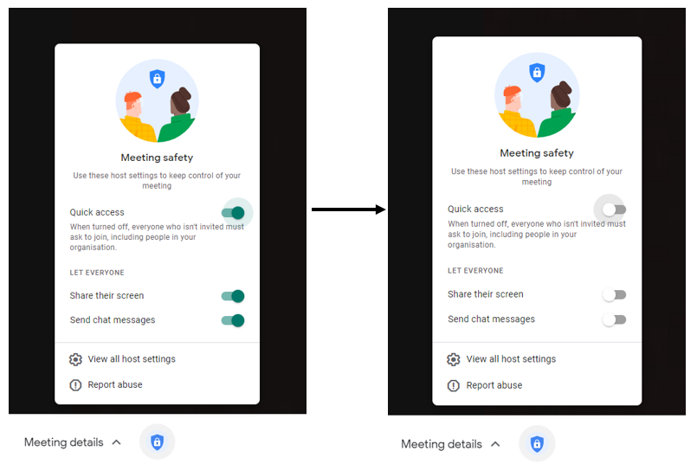

Please see the following for updates concerning safeguarding in relation to home learning:
- COVID-19 amendments to the Child Protection Policy this also details reference to remote learning curriculum and risks online.
This policy is available on our website.

6. Monitoring arrangements
This policy will be reviewed every two years by the Senior Leadership Team

7. Links with other policies
This policy is linked to our:
- Behaviour policy
- Child protection policy and coronavirus addendum to our child protection policy
- Data protection policy and privacy notices
- Home-school agreement
- ICT and internet acceptable use policy
- Online safety policy
https://www.gov.uk/government/publications/remote-education-good-practice/remote-education-good-practice

